

Software Tool and Utility Validation
Q-0007
Revision A

Revision History
Rev | Status | Date | Author | CO # | Description
A | Draft | 3/29/06 | S. Doyle | TBD | Initial Release

Training
Role | New | Trained in previous rev.
Managers | Read the document | Not applicable for Rev A
Software Tool Validators | Read the document | Not applicable for Rev A
Other MedCommons | Core Quality System Training | Not applicable for Rev A

Purpose
Software Tool and Utility Validation ensures that software used in design, production, distribution, support, and quality system applications performs its intended use correctly and does not introduce unacceptable risk.

Scope
Software Tool and Utility Validation applies to all software used in design, production, distribution, support, and quality system applications whether commercial off-the-shelf (COTS) or customer-developed by or for MedCommons, Inc.

It does not apply to software that is developed by MedCommons. Product software is validated per Q-0023, Product Software Validation and Verification. However, it may be the case that software tools that ship with the product (e.g., Apache’s Axis library) will require validation.

Responsibilities

Managers
Managers ensure that only software that has been evaluated and validated per this process is used in MedCommons quality system processes and processes that affect product quality.

Software Tool Validators
Validators perform validations per this procedure.

MedCommons Personnel
MedCommons personnel do not use software that has not been validated for its use in the quality system or impacting product quality. For some software, a minimum version may be established as needed.

Records created
Record type | Form or template | Where filed
Software Tool Validation Records | Q-0007 Form A | SVN – Software Tool Validations

Related Documents
- Q-0001 Quality Manual

Procedure
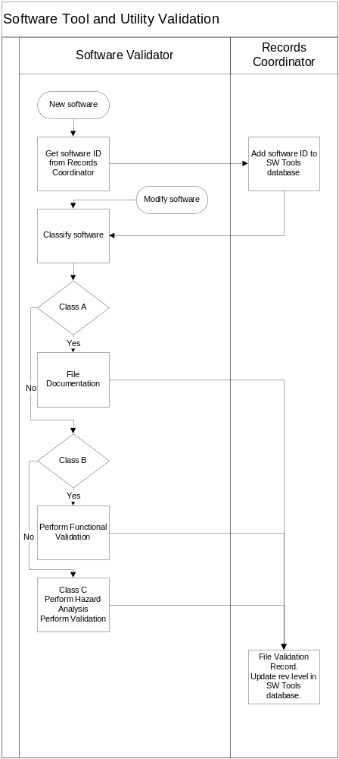

Flowchart Step | Details
Get software ID from Records Coordinator | The SW Tools database provides a reference where personnel can determine the classification and validation status of software.  SW tools should incorporate a revision indicator so that a user can confirm the revision intended for use is indeed validated.
Add software ID to SW Tools database
Classify software | The extent of validation depends on the intended use and its associated risk. MedCommons’ intended use may be reasonably implied for process documentation and actual use.  Class A – No direct effect on product quality or product information. Errors have little safety, business, quality, or regulatory risk. (Examples: Audit schedule database …)  Class B – Moderate effect on product quality or product information. Errors have some safety, business, quality, or regulatory risk. (Examples: Document control system …)  Class C – Direct effect on product quality or product information.  (Examples: Product test software. Customer data manipulation utilities. Product replication software.)  Note: Software such as compilers for product software is Class C. See “Class C?” below for special compiler validation procedures.
Class A?  File documentation. | Minimal validation is needed for Class A. Complete the Validation Record including the classification, the intended use, and a brief description of how proper operation was confirmed.
Class B?  Perform Functional Validation | Validation is required for Class B. Complete the Validation Record including the classification, the intended use, and a completed Validation Test Report. The validation test should be based on one or more typical scenarios to determine proper operation, and on hazard scenarios, if any, that might have significant risk.
Class C?  Perform Hazard Analysis  Perform Validation | Rigorous validation is required for Class C. Complete the Validation Record including the classification, the intended use, a Hazard Analysis and a completed Validation Test Report. The validation test should be based on typical scenarios to determine proper operation, and on hazard scenarios that might have significant risk. Scenarios that “stress” the software function are recommended.  For commercial off-the-shelf software (COTS), MedCommons does not validate all features, just those relied on for MedCommons’ intended use. If practical obtain information on similar use in the industry and known defects.  Direct validation of compilers is impractical. MedCommons must rely on knowledge of similar uses and known defects. The validation of the product software provides some assurance of correct compiler function. Product software changes which will be subject to limited regression testing should avoid using recently updated compilers. While it is acceptable for developers’ machines to use the most up-to-date compilers, the build machine should always run a version that is known to be stable.
File Validation Record. Update rev level in SW Tools database. | The validator may directly file the Validation Record. If so, the Records Coordinator confirms the filing and updates the SW Tool database.

